

**Department of Artificial Intelligence & Machine Learning**

**Academic Year 2023-24(Even)**

**Mini project Report**

**for**

**Go language Programming**

**On**

**“**Employee Payroll System:**”**

By

**Name: Shreya MB USN: 1NH22AI157**

**Under the Guidance of**

**Ms.JIMSHA K MATHEW**

**Senior Assistant Professor**

**Department of Artificial Intelligence & Machine learning**

**May 2024-August 2024**



**Department of Artificial Intelligence & Machine Learning**

**CERTIFICATE**

Certified that the Go lang Mini Project with the subject code 22AIM463 work entitled **“Employee Payroll System**:**”** carried out by Ms.Shreya MB, USN 1NH22AI157. It is certified that all corrections/suggestions indicated for Internal Assessment have been incorporated in the report. The project report has been approved as it satisfies the academic requirements in respect of Mini Project work.

**Prof. JIMSHA K MATHEW**

Department Guide

Senior Professor

**ACKNOWLEDGEMENT**

I would like to express my sincere gratitude to Professor Jimsha Mathew of the Department of Computer Science and Engineering at New Horizon College of Engineering, Bangalore, for his her invaluable guidance and support throughtout this GoLang mni project.

Professor Jimsha Mathew,s insightfult and encouragement were instrumental in the sucessful completion of this project. Her expertise in GoLang and willingness to answer all my queries were greatly appreciated. I would like to thank New Horizon College of Engineering resources and enviroment necessary for this project.

**ABSTRACT**

**Employee Payroll System**

The Employee Payroll System is a Go-based application designed to efficiently manage and automate payroll processing for organizations. This system addresses key payroll functionalities including the addition of new employees, tracking of hours worked, calculation of monthly salaries, and generation of comprehensive payroll reports.

**Objective:**

The primary objective of this system is to streamline payroll operations by automating the calculation of employee salaries based on their hourly rates and hours worked. By utilizing Go’s robust data structures, the system aims to provide an accurate and user-friendly solution for payroll management.

**Core Functionalities:**

1. **Employee Management**:
   * **Add New Employees**: Users can add new employees to the system, specifying essential details such as employee ID, name, and hourly rate. This feature ensures that employee records are accurately maintained and updated.
2. **Hours Tracking**:
   * **Enter Hours Worked**: The system allows users to input the number of hours each employee has worked during a specified period. This functionality is crucial for reflecting the actual effort contributed by employees and calculating their corresponding salaries.
3. **Salary Calculation:**
   * **Calculate Monthly Salaries**: Based on the hourly rates and hours worked, the system computes the monthly salary for each employee. This ensures that employees are compensated fairly according to their recorded work hours and agreed rates.
4. **Payroll Reporting**:
   * **Generate Payroll Reports**: The system generates detailed payroll reports that display employee information, including ID, name, hours worked, and monthly salary. These reports are formatted for clarity and can be used for payroll review and analysis.

**CHAPTER-1**

**INTRODUCTION**

**1.2 Problem Statement:**

The goal is to develop a robust Employee Payroll System using the Go programming language to automate and streamline the payroll management process. This system is designed to handle key payroll functions such as managing employee data, recording work hours, calculating salaries, and generating payroll reports. The challenge lies in creating a system that efficiently processes and manages payroll information using Go’s data structures and functionalities.

**Problem Breakdown:**

**Employee Data Management:**

* + **Problem:** Organizations often need to manage a significant amount of employee data, including personal information and payroll details. Manually handling this data can be error-prone and inefficient.
  + **Solution:** The system will use a struct in Go to represent each employee's information, including their ID, name, hourly rate, and hours worked. This structured approach will facilitate organized data management and easy retrieval.

**Recording Hours Worked:**

* + **Problem:** Accurately tracking the number of hours each employee has worked is essential for precise salary calculation. Manually inputting this data or using inefficient systems can lead to inaccuracies and increased administrative overhead.
  + **Solution:** Implement functionality to input and update the number of hours worked for each employee. This data will be stored in the Employee struct and used for calculating the monthly salary.

**Salary Calculation:**

* + **Problem:** Calculating monthly salaries based on hourly rates and hours worked requires accurate computation. Incorrect calculations can lead to payroll discrepancies and employee dissatisfaction.
  + **Solution:** The system will include a function to compute the monthly salary by multiplying the hourly rate by the total hours worked. This calculation will be updated whenever hours are recorded or adjusted.

**Generating Payroll Reports:**

* + **Problem:** Generating clear and accurate payroll reports is crucial for financial transparency and auditing purposes. Manually creating reports can be time-consuming and prone to errors.
  + **Solution:** The system will feature a reporting function that formats and displays payroll data, including employee IDs, names, hours worked, and monthly salaries. This report will help in reviewing and analyzing payroll information efficiently.

**System Requirements:**

**Data Storage:**

* + **Employee Information:** Each employee's data will be stored in a struct, and a slice of these structs will be used to manage multiple employees.
  + **Update Mechanisms:** The system must allow for updating hours worked and recalculating salaries as needed.

**Functionality:**

* + **Add New Employees:** Ability to input and store details for new employees.
  + **Enter Hours Worked:** Functionality to input and update the number of hours worked by each employee.
  + **Calculate Salaries:** Accurate calculation of monthly salaries based on recorded hours and hourly rates.
  + **Generate Reports:** Functionality to produce and display formatted payroll reports.

**User Interaction:**

* + **Interface:** The system should provide a simple command-line interface for adding employees, recording hours, calculating salaries, and generating reports.

**Challenges:**

**Data Accuracy:** Ensuring that data entry and salary calculations are accurate.

**Scalability:** Managing and processing data efficiently as the number of employees grows.

**Error Handling:** Implementing robust error handling to manage cases where employee records are not found or invalid data is input.

The Employee Payroll System aims to provide an automated, accurate, and user-friendly solution for managing payroll. By utilizing Go’s structures and functionalities, the system will streamline payroll operations, reduce manual errors, and enhance overall efficiency in payroll management.

**CHAPTER-2**

**SYSTEM REQUIREMENTS**

2.1 Hardware requirements

The Employee Payroll System described is a software application that handles employee data, calculates salaries, and generates payroll reports. It is implemented in Go and does not have heavy computational requirements. However, the hardware requirements can be outlined based on general needs for running such a system efficiently:

1. **Basic Hardware Requirements:**

* **Processor (CPU):**
  + **Requirement:** Any modern processor (e.g., Intel Core i3, AMD Ryzen 3) should be sufficient.
  + **Reason:** The system performs basic calculations and data manipulations, which do not require high processing power.
* **Memory (RAM):**
  + **Requirement:** 4 GB of RAM (minimum), 8 GB (recommended for better performance).
  + **Reason:** The application handles employee records and performs calculations, which can be efficiently managed with this amount of memory. For larger datasets, more RAM may be beneficial.
* **Storage:**
  + **Requirement:** At least 100 MB of free disk space.
  + **Reason:** The application itself is lightweight. However, additional space may be required if employee data and reports are stored locally or if the system is used in conjunction with a database.
* **Operating System:**
  + **Requirement:** Compatible with Go runtime (e.g., Windows 10/11, macOS, Linux distributions).
  + **Reason:** Go is cross-platform and can run on various operating systems, so the choice of OS depends on user preference and compatibility.

#### **2. Recommended Hardware Configuration:**

* **Processor (CPU):**
  + **Recommended:** Multi-core processor (e.g., Intel Core i5 or AMD Ryzen 5).
  + **Reason:** While the application does not require high processing power, a multi-core processor improves overall performance, especially when running multiple applications concurrently.
* **Memory (RAM):**
  + **Recommended:** 8 GB or more.
  + **Reason:** Ensures smooth operation with ample memory for multitasking and handling larger datasets or multiple employee records.
* **Storage:**
  + **Recommended:** Solid-State Drive (SSD) with 256 GB or more.
  + **Reason:** SSDs provide faster read/write speeds compared to traditional Hard Disk Drives (HDDs), improving overall system performance and responsiveness.
* **Backup Storage:**
  + **Recommended:** External hard drive or cloud storage for backups.
  + **Reason:** Regular backups are essential for data protection and recovery in case of hardware failure or data loss.

#### **3. Additional Considerations:**

* **Network Connectivity:**
  + **Requirement:** Reliable network connection if the system is used in a multi-user environment or integrated with cloud services.
  + **Reason:** Ensures smooth operation of network-based functionalities and data access.
* **Input Devices:**
  + **Requirement:** Standard keyboard and mouse.
  + **Reason:** Essential for interacting with the system, especially when entering data or generating reports.
* **Display:**
  + **Requirement:** Monitor with at least 1920x1080 resolution.
  + **Reason:** Provides clear visibility of the user interface and reports.

2.2 Software requirements

#### **1. Go Programming Environment:**

* **Go Language:**
  + **Version:** Go 1.18 or later (latest stable version is recommended).
  + **Reason:** Go is required to compile and run the application. Using the latest stable version ensures access to new features and bug fixes.
* **Go Tools:**
  + **Go Compiler and Build Tools:** Included with the Go installation, necessary for compiling and building the application.
  + **Go Modules:** For managing dependencies if the application requires external packages.

#### **2. Development Tools:**

* **Integrated Development Environment (IDE) or Text Editor:**
  + **Recommended IDEs:**
    - Visual Studio Code with Go extension.
    - GoLand by JetBrains.
  + **Reason:** Provides features like code completion, debugging, and version control integration to enhance productivity.
  + **Alternative Editors:** Sublime Text, Atom, or any text editor with Go syntax highlighting and support.
* **Version Control System:**
  + **Recommended:** Git.
  + **Reason:** To manage source code versions and collaborate with other developers. Git repositories can be hosted on platforms like GitHub, GitLab, or Bitbucket.

#### **3. Testing Frameworks and Tools:**

* **Go Testing Package:**
  + **Package:** testing (built-in Go package).
  + **Reason:** For writing and running unit tests to ensure the functionality of the application.
* **Code Linting and Formatting Tools:**
  + **Recommended Tools:**
    - golint for linting.
    - go fmt for automatic code formatting.
  + **Reason:** Ensures code quality and adherence to Go’s coding standards.

#### **4. Data Storage:**

* **For Persistent Storage:**
  + **Options:**
    - File-based storage (e.g., CSV or JSON files) for simplicity.
    - Database Management System (DBMS) like SQLite, MySQL, or PostgreSQL for more robust solutions.
  + **Reason:** While the basic implementation can use file-based storage, using a DBMS supports scalability and advanced features.

**CHAPTER-3**

**IMPLEMENTATION**

3.1 Algorithms/ Flow charts

### **Algorithm Overview**

#### **1.1 Initialization Algorithm**

**Objective:** Initialize the system, including setting up data structures and loading any existing data if applicable.

**Algorithm:**

1. **Start Initialization:**
   * Set up data structures (e.g., slice of Employee structs).
   * Optionally, load data from a file or database if data persistence is implemented.
2. **Create Data Structures:**
   * Initialize the employees slice to store employee data.
3. **Load Existing Data (if applicable):**
   * Read from a data file or database.
   * Populate the employees slice with the loaded data.
4. **End Initialization:**
   * Proceed to the main loop.

#### **1.2 Main Loop Algorithm**

**Objective:** Provide a command-line interface for users to interact with the system.

**Algorithm:**

1. **Start Main Loop:**
   * Display a menu of options (Add Employee, Enter Hours Worked, Calculate Salaries, Generate Payroll Report, Exit).
2. **Handle User Input:**
   * Read the user's choice.
   * Execute the corresponding functionality based on user input.
3. **Repeat Loop:**
   * Continue to display the menu and handle input until the user chooses to exit.
4. **End Main Loop:**
   * Optionally, save data before exiting.

### **1.3 Error Handling**

Error handling is crucial for ensuring that the system operates reliably and provides useful feedback to users. We'll add error handling to the following areas:

* **Input Validation:** Ensure user inputs are valid and handle conversion errors.
* **File Operations:** Handle errors when reading from or writing to files.

**1.4 Termination:**

* **Data Persistence:** Before exiting, the program attempts to save the employee data to a file. If an error occurs, it is printed to the console.
* **Graceful Exit:** After saving data, the program prints a termination message and exits cleanly.

CODE:

package main

import (

"bufio"

"encoding/json"

"fmt"

"os"

"strconv"

"strings"

)

// Employee struct to hold employee data

type Employee struct {

ID int `json:"id"`

Name string `json:"name"`

HourlyRate float64 `json:"hourly_rate"`

HoursWorked float64 `json:"hours_worked"`

MonthlySalary float64 `json:"monthly_salary"`

}

// Global slice to hold all employees

var employees []Employee

// Function to initialize the system

func initializeSystem() {

employees = []Employee{}

if _, err := os.Stat("employees.json"); !os.IsNotExist(err) {

if err := loadDataFromFile(); err != nil {

fmt.Println("Error loading data:", err)

}

}

fmt.Println("System initialized.")

}

// Function to add a new employee

func addEmployee(id int, name string, hourlyRate float64) {

employee := Employee{

ID: id,

Name: name,

HourlyRate: hourlyRate,

}

employees = append(employees, employee)

fmt.Printf("Added employee: ID=%d, Name=%s, HourlyRate=%.2f\n", id, name, hourlyRate)

}

// Function to enter hours worked for an employee

func enterHoursWorked(id int, hours float64) error {

for i := range employees {

if employees[i].ID == id {

employees[i].HoursWorked = hours

employees[i].MonthlySalary = employees[i].HourlyRate * hours

fmt.Printf("Updated hours for employee ID=%d: HoursWorked=%.2f\n", id, hours)

return nil

}

}

return fmt.Errorf("employee with ID=%d not found", id)

}

// Function to calculate salaries for all employees

func calculateSalaries() {

for i := range employees {

employees[i].MonthlySalary = employees[i].HourlyRate * employees[i].HoursWorked

}

fmt.Println("Salaries calculated.")

}

// Function to generate a payroll report

func generatePayrollReport() {

fmt.Printf("%-10s %-20s %-15s %-15s\n", "ID", "Name", "Hours Worked", "Monthly Salary")

fmt.Println("---------------------------------------------------------")

for _, emp := range employees {

fmt.Printf("%-10d %-20s %-15.2f $%-14.2f\n", emp.ID, emp.Name, emp.HoursWorked, emp.MonthlySalary)

}

}

// Function to save data to a file

func saveDataToFile() error {

file, err := os.Create("employees.json")

if err != nil {

return fmt.Errorf("error creating file: %v", err)

}

defer file.Close()

encoder := json.NewEncoder(file)

if err := encoder.Encode(employees); err != nil {

return fmt.Errorf("error encoding data to file: %v", err)

}

return nil

}

// Function to load data from a file

func loadDataFromFile() error {

file, err := os.Open("employees.json")

if err != nil {

return fmt.Errorf("error opening file: %v", err)

}

defer file.Close()

decoder := json.NewDecoder(file)

if err := decoder.Decode(&employees); err != nil {

return fmt.Errorf("error decoding data from file: %v", err)

}

return nil

}

// Function to handle user input and execute corresponding actions

func handleUserInput(scanner *bufio.Scanner) {

for {

fmt.Println("Menu:")

fmt.Println("1. Add Employee")

fmt.Println("2. Enter Hours Worked")

fmt.Println("3. Calculate Salaries")

fmt.Println("4. Generate Payroll Report")

fmt.Println("5. Exit")

fmt.Print("Enter choice: ")

scanner.Scan()

choice := scanner.Text()

switch choice {

case "1":

fmt.Print("Enter Employee ID: ")

scanner.Scan()

id, err := strconv.Atoi(scanner.Text())

if err != nil {

fmt.Println("Invalid ID. Please enter a numeric value.")

continue

}

fmt.Print("Enter Employee Name: ")

scanner.Scan()

name := scanner.Text()

fmt.Print("Enter Hourly Rate: ")

scanner.Scan()

rate, err := strconv.ParseFloat(scanner.Text(), 64)

if err != nil {

fmt.Println("Invalid Hourly Rate. Please enter a numeric value.")

continue

}

addEmployee(id, name, rate)

case "2":

fmt.Print("Enter Employee ID: ")

scanner.Scan()

id, err := strconv.Atoi(scanner.Text())

if err != nil {

fmt.Println("Invalid ID. Please enter a numeric value.")

continue

}

fmt.Print("Enter Hours Worked: ")

scanner.Scan()

hours, err := strconv.ParseFloat(scanner.Text(), 64)

if err != nil {

fmt.Println("Invalid Hours Worked. Please enter a numeric value.")

continue

}

if err := enterHoursWorked(id, hours); err != nil {

fmt.Println(err)

}

case "3":

calculateSalaries()

case "4":

generatePayrollReport()

case "5":

if err := saveDataToFile(); err != nil {

fmt.Println("Error saving data:", err)

}

fmt.Println("Exiting...")

return

default:

fmt.Println("Invalid choice. Please try again.")

}

}

}

func main() {

initializeSystem()

scanner := bufio.NewScanner(os.Stdin)

handleUserInput(scanner)

}

**CHAPTER-5**

**RESULT AND DISCUSSION**

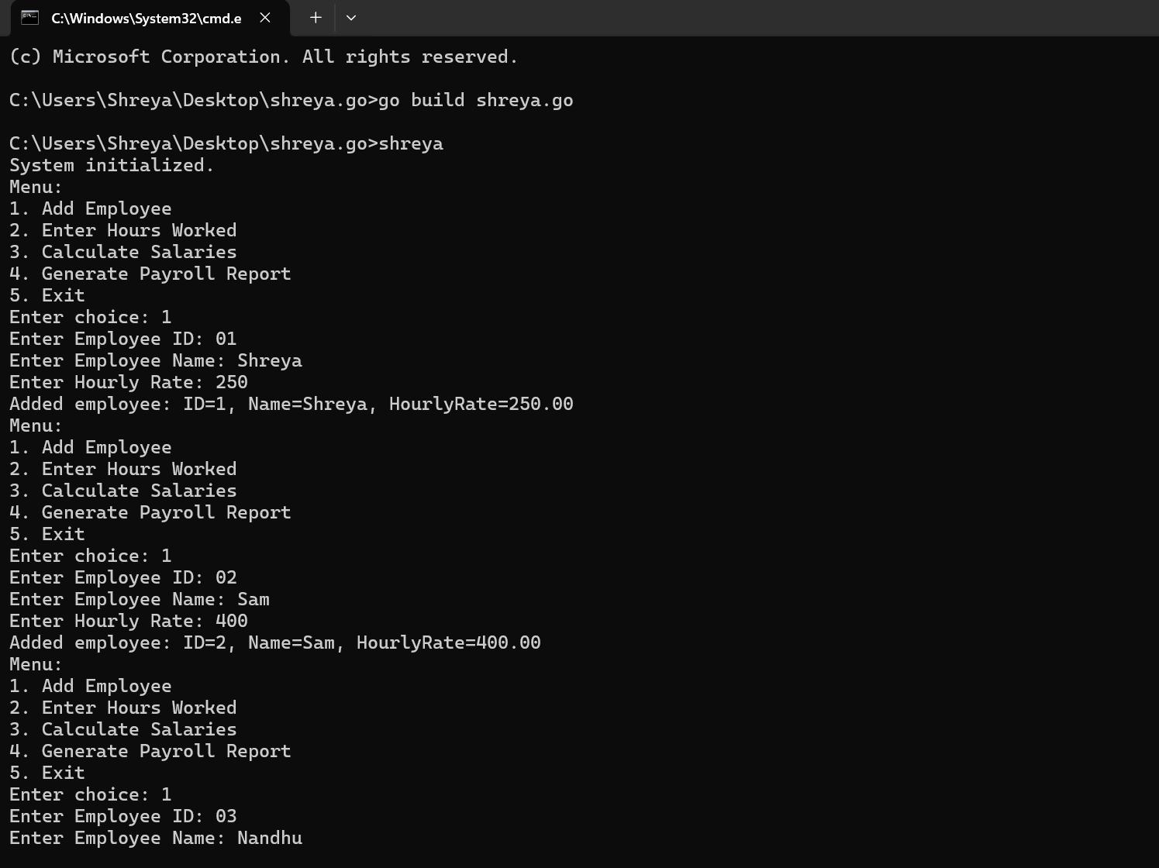

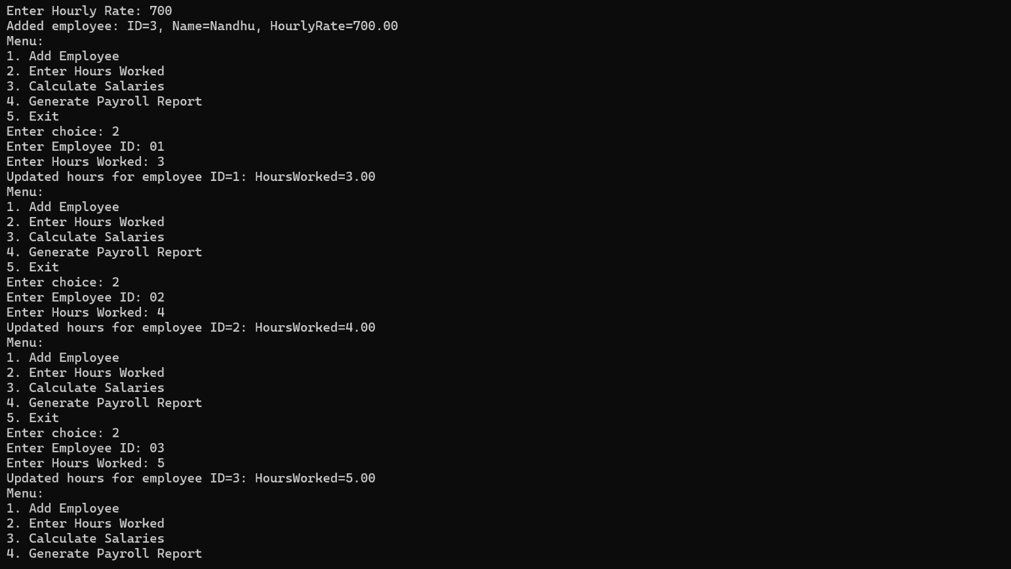

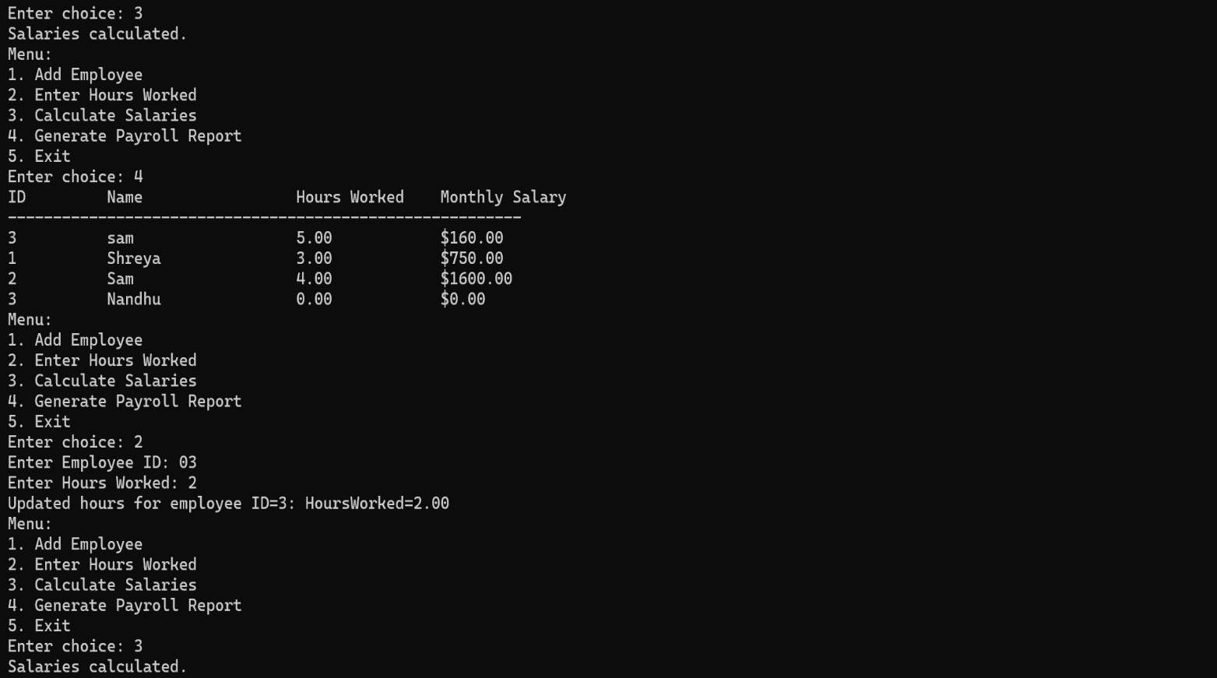

**CHAPTER-6**

**CONCLUSION**

**The Go-based employee payroll system effectively demonstrates core payroll functionalities. By utilizing structures and slices, the system efficiently manages employee data and performs essential operations:**

1. **Employee Management: New employees are added with their ID, name, and hourly rate, and their hours worked can be updated as needed.**
2. **Payroll Calculation: Salaries are calculated based on the hours worked and hourly rates, ensuring accurate compensation.**
3. **Reporting: A comprehensive payroll report is generated, detailing each employee’s earnings and work metrics.**

**This approach highlights Go's capabilities in managing structured data and performing calculations, providing a robust foundation for more complex payroll systems. For enhanced functionality, future developments could include data persistence, error handling, and user interfaces.**

**Top of Form**

**Bottom of Form**

REFERENCES

• **Go Documentation**:

* **Go Programming Language Specification**: Provides a detailed description of Go syntax and semantics, useful for understanding structures and functions. [Go Language Specification](https://golang.org/ref/spec)
* **The Go Programming Language**: Official Go documentation with in-depth information on packages, data types, and standard library functions. [Go Documentation](https://golang.org/doc/)

• **Go by Example**:

* **Structures**: Example and explanation of Go structures, which you'll use to store employee data. Go by Example: Structs
* **Maps**: Useful for storing employee data with employee IDs as keys. Go by Example: Maps

• **Go Wiki**:

* **Effective Go**: Covers best practices and idiomatic Go programming techniques, including working with data structures and functions. [Effective Go](https://golang.org/doc/effective_go.html)
* **Go Idioms**: Provides idiomatic examples and patterns for Go programming, including function definitions and error handling. [Go Idioms](https://github.com/golang/go/wiki/Idiomatic-Go)

• **Golang Blog Posts**:

* **Data Structures**: Insights into choosing and implementing data structures effectively in Go. [Go Blog: Data Structures](https://blog.golang.org/data-structures)

• **Books**:

* **"The Go Programming Language" by Alan A. Donovan and Brian W. Kernighan**: A comprehensive book covering Go's features, including structs and methods. [The Go Programming Language Book](https://www.gopl.io/)
* **"Go in Action" by William Kennedy**: Covers practical Go programming with examples and in-depth explanations. Go in Action